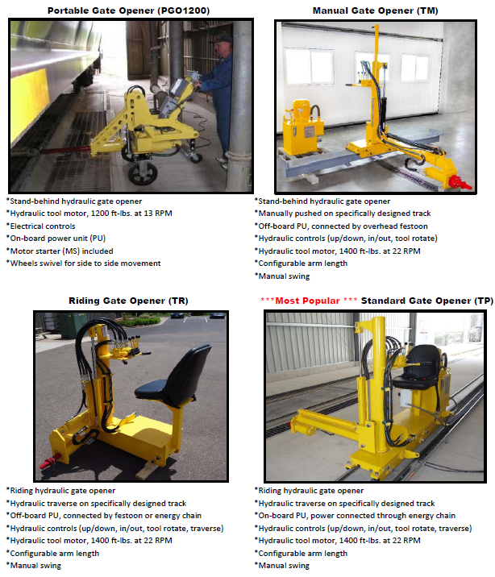

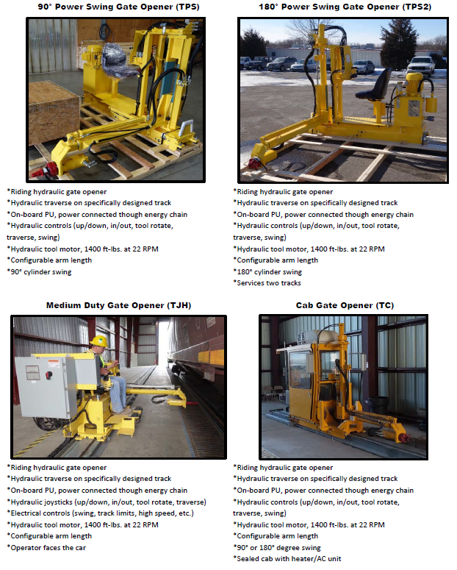

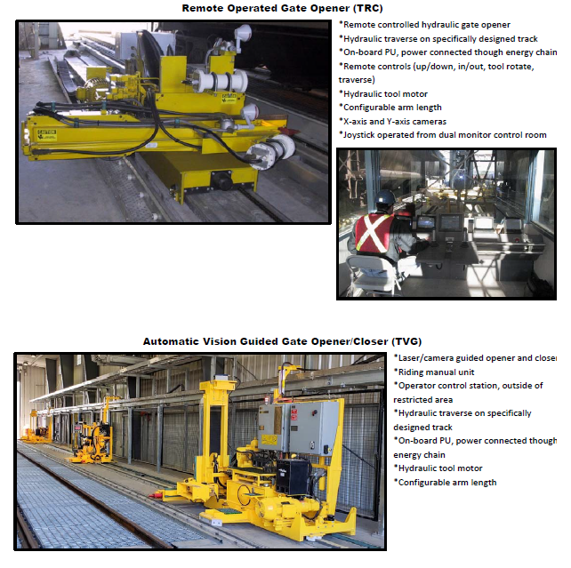

Customer:
Address Line 1:
Address Line 2:
City, State Zip:
Contact:
Title:
Email:
Office Phone:
Cell Phone:

The questions below help determine the most efficient and economic solution for your railcar moving application. Factors that can alter the scope of the applications are as follows: the number of railcars moved, the weight of the railcars, degree of curve(s), number of cars on the curve(s), the quantity of track switches, minimum temperature, and railcar braking force. These all affect the line pull required.
1. What style of gate opener are you interested in?
2. Where will the gate opener be located?
3. Are you the end user or will it be resold?
4. Will it be in a building?
5. How many cars will it be opening daily/weekly?
6. What commodity is being unloaded?
7. Will it be a right hand or left hand? (Operator faces direction of incoming cars)
8. What is the pit length? (This will determine track length)
9. Would the electrical junction box go at the center of the track or the front end of the track? (Will the Igus
energy chain be a center entry or an end entry?)
10. Does it have to be outside a clearance line? Will there be locomotives passing by?
11. What is the nearest obstruction? (This will determine the arm length and in/out stroke. Also, distance from center of pit to center of gate opener, 86", 101", 107", or 118")
12. Will it be manual swing or power swing? If power swing, 90° or 180°?
13. Will it need an oil heater?
14. Will it need a vibrator?
15. What voltage is needed, 480VAC or 575VAC?
16. Would Calbrandt supply the motor starter?
17. What is the area classification/NEMA Rating?
18. Is it a corrosive environment?
19. What is the preferred oil type? (Standard, food grade, etc.)
End Customer:
Notes:
