Customer:
Address Line 1:
Address Line 2:
City, State Zip:
Contact:
Title:
Email:
Office Phone:
Cell Phone:
The questions below help determine the most efficient and economic solution for your railcar moving application. Factors that can alter the scope of the applications are as follows: the number of railcars moved, the weight of the railcars, degree of curve(s), number of cars on the curve(s), the quantity of track switches, minimum temperature, and railcar braking force. These all affect the line pull required.
Please complete in the spaces provided and circle appropriate specification.
Project description:

Project location:
City, Sate/Province, Country

Total number of full cars to move?
Total number of empty cars to move?
Gross weight per railcar:
(car + commodity)
(specify ton, or metric ton)
Empty weight of a railcar:
(specify if tons, or metric tons)
Maximum coupler to coupler length in feet:
(affects Indexer Stroke):
Minimum coupler to coupler length
in feet:
What is the commodity?
Environment:  (due to commodity or environment) | Non-Corrosive or Corrosive
Type of railcar: | Hopper or Tanker
Do you have drawings of the railcars to be used? (please provide if yes) | Yes or No
Will the car mover need to push on an empty car in order to spot a car? | Yes or No
Is this a loading or unloading application, or both?
If unloading, is a Gate Opener required? | Yes or No
If unloading, what is the pit length?
(to determine number of unloading positions required)
If unloading, how accurately does the car mover need to spot the car to properly align it with the pit or unloading system?
(i.e.: + / - 6”)
If loading, does the car need to be spotted more than once to fill it?  - If yes, how many times? | Yes or No
If loading, how accurately does the car mover need to spot the car to properly align it with the load spout?
(i.e.: + / - 6”)
Is more than 1 car loaded at a time?  - If yes, how many? | Yes or No
Direction of travel:
(one way, reversing, or both)
What will the Railcar Mover be mounted on? | Ties or Concrete
Is this a new application or a renovation?
Is there a Track Scale?  - If so, what type of Scale? | Yes or No
Will any of the cars in the string moved by the Indexer need to be pushed through a curve?  - If so, what is the radius or degree of that curve?  - If so, how many cars are in the curve at one time?  - Are the cars in the curve full or empty cars? | Yes or No
Is there a grade?  - If so, what is the % of the grade?  - If so, is the Indexer moving the cars up or down the grade?  Note: Rail cars will start to roll on their own at approximately a 0.15% grade | Yes or No
Qty of full cars on the grade?
Qty of empty cars on the grade?
Will car brakes be applied when moving cars? | Yes or No
Are there track switches present?  - If so, what is the qty and size?  - If so, are the switches on the full or empties side? | Yes or No
What is the winter minimum operating temperature?
(specify if F. or C.)
Operating frequency?
(estimated number of railcars handled per day / per week.)
What is the condition of the track?
What is the rail size?
(e.g.: 115 lb.)
What is the Railcar Mover stroke that is required?
(it is typically 1 car length)
What speed does the Railcar Mover need to move the railcars?
(e.g.: 20, 30, 40, 50, or 60 FPM)
Will the Railcar Mover be located indoors or outdoors?
Is a Hazardous Duty Electrical Classifications required?
(i.e.: Class I, Division 2, Group D)
(i.e.: Class II, Division 1, Group G)
Will a Shuttle Wagon, or locomotive pass over the Car Mover? | Yes or No

Track Elevation (as compared to concrete, see picture below)?
(i.e.: top of rail level with concrete, or 115# rail mounted on concrete)
Listed below are three track elevation examples, from left to right:
- "top of rail to concrete (unknown dimension),
- "bottom of rail level with top of concrete", and
- "top of rail level with top of concrete".
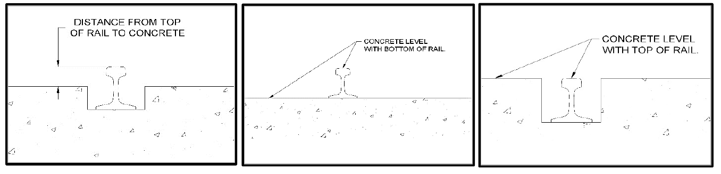

Please circle which one matches your rail. Provide dimensions or additional information if required.

Note: Calbrandt provides various styles of Railcar Movers:
- Low Dog (pushes low on the bogie frame).
- Cantilever (pushes low on the bogie frame. Mounted outside of rail, so good choice for applications with scales).
- Coupler Arm (pushes on the coupler, mounted outside of rail, so good choice for applications with scales).
- Body Pin (Pulls on railcar bodies “Pull Here” hole.
- High Dog (pushes high on the bogie frame, good for higher loads).
- Axle (pushes on the axle).
- Dual Axle (pushes two axles of 1 car, good for higher loads).

Note: Calbrandt railcar movers, can be “Railcar Indexers”, “Railcar Progressors”, or “Railcar Indexer / Progressors”.
- Indexers move railcars in incremental moves, with a pause during the retract stroke.
- Progressors continuously move the railcars.
- Indexer / Progressors automatically switch between the two modes based on the current line pull. Indexer when heavy line pull, progressor when lighter.

Note: Calbrandt provides “Retarders” for accurately spotting railcars and for holding railcars

This below is left intentionally blank for additional notes, pictures, etc.

